To: City Executive Board

Date: 10 September 2015

Report of: Head of Financial Services

Title of Report: Treasury Management Annual Report 2014/2015

Summary and Recommendations

Purpose of report: The report sets out the Council’s treasury management activity and performance for 2014/2015 and recommends some changes to the Treasury Management Strategy for 2015/16.

Key decision No

Executive lead member: Councillor Ed Turner, Executive Board Member for Finance, Asset Management and Public Health
Policy Framework: Treasury Management Strategy

Recommendations: That the City Executive Board resolves to:

- note the report; and
- recommend Council to resolve to approve the Revised MRP Policy as set out in Appendix 1 and approve the amendment to the Non-Specified Investments list attached at Appendix 2

Appendices:
Appendix 1 – Revised MRP Policy
Appendix 2 – Amended Non-Specified Investments list
Appendix 3 – Risk Register

Executive Summary

- The Council held investments of approximately £51 million as at 31 March 2015. Interest earned during the year was approximately £0.675 million against an income target of £0.658 million.

- The average rate of return on the Council’s investments in 2014/2015 was 1.18% compared to 0.92% in 2013/14. This was above the Council’s performance target of 1.0% and primarily due to increased investments in property funds.

- The Council has £0.379 million outstanding with the failed Icelandic Banks. £0.082 million was received in year, and it is expected that the majority of the remaining funds will be received in due course. Further information can be found in paragraphs 24-26.

- The Council held £199.4 million of fixed rate Public Works Loan Board (PWLB) debt as at 31 March 2015. The loans include £198.5 million borrowed in March 2012 to fund the buy-out of the Housing Revenue Account (HRA). All of the debt relates to Housing and the maturity profile ranges from 9 to 45 years. Interest paid on the debt in 2014/2015 was £6.71 million

Background

- The primary principle governing the Council’s investment criteria is Security of investment, with Liquidity and Yield being secondary considerations.

- The Council has a statutory duty to set, monitor and report on its prudential indicators in accordance with the Prudential Code, which aims to ensure that the capital investment plans of authorities are affordable, prudent and sustainable.

- When considering whether to borrow, the Council’s Debt Strategy requires a number of factors to be considered. These include:
- prevailing interest rates
- the profile of the Council’s debt portfolio
- the type of asset being financed
- the availability of cash balances to finance capital expenditure.

- The Council fully complied with its Treasury Management Strategy in relation to both debt and investment management in 2014/2015.

- The prudential indicators detailed in the body of this report relate to 2014/2015, and compare the Council’s outturn position against the target set.

- At its meeting on the 30 July 2015, the City Executive Board determined to enter into an investment agreement to provide properties as part of the Council’s Homelessness function. Consequently, some changes are necessary to the Council’s non-specified investments list and the Minimum Revenue Provision (MRP) Policy in the Treasury Strategy for 2015/16 as per paragraphs 38 and 39.

Financing the Capital Programme 2014/15

- Table 1 below shows actual capital expenditure and financing compared to the revised budget.

Table 1
Capital Expenditure | 2014/15 | 2014/15 | Variation
 | Approved Budget | Actual
 | £'000 | £'000 | £'000
Non-HRA Capital Expenditure | 32,271 | 26,750 | (5,521)
HRA Capital Expenditure | 27,862 | 21,962 | (5,900)
Total Capital Expenditure | 60,133 | 48,712 | (11,421)
Resourced by:
Developer Contributions | 569 | 834 | 265
Capital Receipts | 11,159 | 17,763 | 6,604
Capital Grants and contributions | 5,147 | 1,760 | (3,387)
Major Repairs Reserve | 22,491 | 8,704 | (13,787)
Prudential Borrowing | 2,907 | 0 | (2,907)
Revenue | 17,860 | 19,651 | 1,791
Total Capital Resources | 60,133 | 48,712 | (11,421)

- The key variations relate to the following movements in the Capital Programme:
General Fund
Net Slippage
- £3.720 million on Superconnected Cities.
- £0.268 million on Flood alleviation at Northway and Marston
- £0.118 million on Community Centres
- £0.223 million on Investment Properties
- £0.115 million on Templar Square
- £0.953 million budget moved from 2015/16 into 2014/15 for Housing property acquisitions
- £0.629 on indoor sports facilities
- £0.104 on Parks & Cemeteries
- £0.894 on vehicles
- £0.586 million on car park improvements
- £0.103 million feasibility budgets
Additions to budgeted allocations
- £0.110 million on Town Hall improvements
- £0.592 million on the purchase of St Aldates Chambers
- £0.250 million on the Empty Homes Revolving Fund
Housing Revenue Account
Net Slippage
- £0.157 million on external contracts
- £3.166 million on Rose Hill Community Centre
- £1.319 million on New Build
- £0.328 million on Great estates estate enhancement
- £0.722 million on internal contracts
In addition to the above, the Council took a proactive decision to use capital receipts in financing the General Fund Capital Programme instead of borrowing to finance vehicles capital expenditure

The Council’s Overall Borrowing Need
- The Council’s underlying need to borrow, or Capital Financing Requirement (CFR), is a gauge of the Council’s level of indebtedness. It represents all prior years’ net capital expenditure which has not been financed by other means (revenue, capital receipts, grants etc.).

- The CFR can be reduced by:
  - The application of additional capital resources, such as unapplied capital receipts; or
  - By charging a Minimum Revenue Provision (MRP), or a Voluntary Revenue Provision (VRP)

- Table 2 below shows the Council’s CFR as at the 31st March 2015, this is a key prudential indicator, and shows that actual borrowing is below the CFR:

Table 2
CFR | 31st March 2015 | 31st March 2015 | Variation
 | Estimate | Actual
 | £'000 | £'000 | £'000
Opening Balance | 218,108 | 220,550 | 2,442
Prudential Borrowing | 2,907 | 0 | (2,907)
Minimum Revenue Provision | (3,064) | 0 | 3,064
Leases Adjustment | 0 | (19,909) | (19,909)
CFR Closing Balance | 217,951 | 200,641 | (17,310)
External Borrowing | 200,638 | 199,423 | (1,215)
Variation | (17,313) | 1,218

The CFR position was adjusted in 2014/15 for the value of finance leases relating to St Aldates and Westgate. On 31st March 2015 the Council purchased the sub lease of St Aldates Chambers for £7.5 million. This removed the obligation on the Council to pay £0.300 million per annum in rent in favour of a 126-year lease obligation of £2,500 per annum. The Council’s Development Agreement (DA) with the Westgate Oxford Alliance (WOA) became unconditional on 5th February 2015 at which point works on site commenced. The transaction resulted in a net increase in assets of around £41.955 million, representing the difference between the old lease on the shopping centre and the new one.

- No new debt was taken out during 2014/15 and as at 31st March 2015 the Council’s total external debt was £199.4 million. This is below the CFR and indicates that the Council continues to internally borrow.

Treasury Position at 31st March 2015
- Whilst the Council’s gauge of its underlying need to borrow is the CFR, the treasury function manages the Council’s actual borrowing position by either:
  - Borrowing to the CFR;
  - Choosing to utilise temporary cash flow funds, instead of borrowing (known as “under borrowing”);
  - Borrowing for future increases in the CFR (borrowing in advance of need)

- The Council’s treasury position as at the 31st March 2015 for both debt and investments, compared with the previous year is set out in Table 3 below:

Table 3
 | 31st March 2014 |  | 31st March 2015
Treasury Position | Principal | Average Rate | Principal | Average Rate
 | £'000 | % | £'000 | %
Borrowing
Fixed Interest Rate Debt | 200,440 | 3.39 | 199,423 | 3.39
Total Debt | 200,440 | 3.39 | 199,423 | 3.39
Investments
Fixed Interest Investments | 47,441 | 0.98 | 35,200 | 0.53
Variable Interest Investments | 14,353 | 0.37 | 5,890 | 0.42
Property Funds | 2,870 | 6.00 | 9,800 | 6.00
Total Investments | 64,664 | 0.92 | 50,890 | 1.18
Net Position | 135,776 |  | 148,533

Prudential Indicators and Compliance Issues
- Some of the prudential indicators provide an overview, others a specific limit on treasury activity. These are detailed below:

- Net Borrowing and the CFR – In order to ensure that borrowing levels are prudent, the Council’s external borrowing (net of investments) over the medium-term must only be for a capital purpose, and not exceed the CFR except in the short-term. In the short term the Council can borrow for cashflow purposes, although this has not been necessary in recent years. Table 4 below highlights the Council’s net borrowing position against the CFR, and shows that it is significantly below the limit, due to the level of internal borrowing that has been undertaken.

Table 4
Net Borrowing & CFR | 31st March 2014 | 31st March 2015
 | Actual | Actual
 | £'000 | £'000
Total Debt | 200,440 | 199,423
Total Investment | 64,664 | 50,890
Net Borrowing Position | 135,776 | 148,533
CFR | 220,550 | 200,641
Under Borrowing | 84,776 | 52,108

- In the current climate, internal borrowing is preferable to borrowing externally as the interest rate payable on an external loan is much higher than that which can be earnt on deposits. Therefore, forfeiting interest receivable on investments is more economical than paying additional interest charges for new external debt. Clearly, if the net borrowing position and/or CFR changed significantly, the prospect of taking on additional debt would be reviewed.

- The Authorised Limit – The Authorised Limit is the ‘affordable borrowing limit’ required by S3 of the Local Government Act 2003. The Council does not have the power to borrow above this level unless it explicitly agrees to do so. Table 5 below demonstrates that during 2014/15 the Council’s gross borrowing was within its Authorised Limit. The Authorised Limit allows the Council to borrow against the future CFR if required, with a little headroom.

Table 5
Authorised Borrowing | 31st March 2014 |  | 31st March 2015
 | Estimate | Actual | Estimate | Actual
 | £'000 | £'000 | £'000 | £'000
Borrowing | 248,000 | 200,440 | 247,000 | 199,423
Other Long Term Liabilities | 1,000 | 0 | 0 | 0
Total Borrowed | 249,000 | 200,440 | 247,000 | 199,423
Amount under Limit | 48,560 |  | 47,577

- The Operational Boundary Limit – the Operational Boundary Limit is the expected borrowing position of the Council during the year. It is possible to exceed the Operational Boundary limit, for a short period of time, providing that the Authorised Borrowing Limit is not breached. Table 6 below shows the limits for the last two financial years. They were not breached during either period.

Table 6
Operational Boundaries | 31st March 2014 | 31st March 2015
 | £'000 | £'000
Borrowing | 237,000 | 236,000
Other Long Term Liabilities | 1,000 | 0
Totals | 238,000 | 236,000

- Actual financing costs as a proportion of net revenue stream – this indicator identifies the trend in the net cost of capital against the net revenue stream and is an indicator of affordability. Table 7 below shows that for the General Fund, the ratio is negative as PWLB loans have been repaid and investment income is positive. The HRA ratio has improved slightly due to improved investment returns compared to the previous year.

Table 7
Actual Finance Costs | 2013/14 | 2014/15
 | £'000 | £'000
Indicators
Original Indicator - Authorised Limit | 249,000 | 247,000
Original Indicator - Operational Boundary | 238,000 | 236,000
Financing Costs as a proportion of Net Revenue Stream - General Fund | -0.7% | -0.15%
Financing Costs as a proportion of Net Revenue Stream - HRA | 18.5% | 17.7%

Icelandic Banks
- During 2008/09 the Council invested £4.5 million with two of the now failed Icelandic banks: £3.0 million was deposited with Heritable Bank and £1.5 million with Glitnir Bank.

- As at 3st March 2015, the Council had received approximately £2.82 million of its original Heritable Bank investment (94%) plus interest. No recent repayments have been received and the prospect of a full recovery is uncertain.

- A further repayment of the outstanding Icelandic Krona (ISK) has been received in respect of the Glitnir Bank investment via an auction of currency. A balance of £0.200 million remains with the potential to recover this in due course.

Investment Income
- The following graph shows the monthly average interest earned by the Council in comparison to the base rate and also in comparison to its benchmarks: 3-months Libid and 7-day Libid.

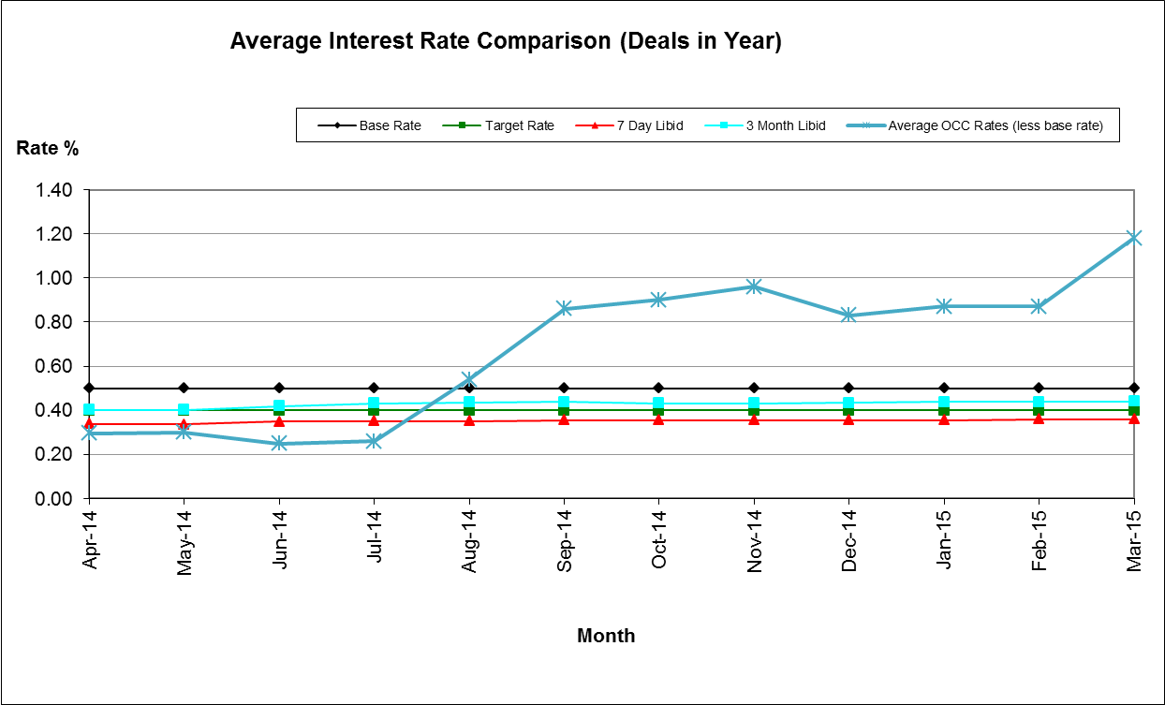

- As illustrated above, the Council’s average monthly rate of return was below benchmark at the beginning of the financial year but exceeded the benchmark from August 2014 onwards. This upward turn is primarily due to investment in a property fund: Lothbury; the Council invested £3.5m in August 2014 and a further £3.5m in September 2014.

- The Council manages its investments in-house and invests with the institutions listed in the Council’s approved counterparty list. The Council invests for a range of periods from overnight to 364 days, dependant on cash flow needs, its interest rate view, the interest rates on offer and durational limits set out in the Council’s Investment Strategy.

- During 2014/15, the Council maintained an average investment balance of £68 million and received an average return of 1.18%. This is above the target of 1% and is mainly due to investment in property funds in the latter part of the year. It is important to note that market rates have continued to drop throughout the financial year and that for many of the approved counterparties, the Council has not been able to achieve the same rate of return as in previous periods.

- The Property Funds are classified as Non-specified Investments within the approved Strategy. The current rate of return on the investments is circa 6% per annum. The value of the Communities, Churches and Local Authorities Fund has increased by 21.06% since April 2013 and the Lothbury fund has increased by 8.65% since August 2014. It should be noted that this price can also fluctuate downwards.

- Actual investment income for 2014/15 was £0.675 million; this was marginally higher than the original budget of £0.658 million. Market rates continue to be very low and as security of investment is the Council’s primary concern, it has not always been possible to invest cash at more favourable rates.

- Fluctuations in the Council’s balances have been managed through a mix of instant access and notice accounts, money market funds and short term deposits (up to 364 days). This approach is in line with the Investment Strategy approved by Council.

Counterparty Changes
- Following a tender process, Barclays Bank UK plc now provides the Council’s banking services.

Strategy Update
- The Treasury Management Strategy for 2014/15 was approved by Council on 18th February 2015. The Council complied with the Strategy throughout the financial year.

- In July 2014, Council agreed a motion to implement an ethical investment policy within its Treasury Management Strategy and the following statement was duly incorporated into the Strategy:

The Council will not knowingly invest directly in businesses whose activities and practices pose a risk of serious harm to individuals or groups, or whose activities are inconsistent with the Council’s mission and values. This would include, inter alia, avoiding direct investment in institutions with material links to:
- Human rights abuse (e.g. child labour, political oppression)
- Environmentally harmful activities (e.g. pollution, destruction of habitat, fossil fuels)
- Socially harmful activities (e.g. tobacco, gambling)

- At its meeting on the 30th July 2015, the Council’s City Executive Board approved an investment into a property fund specifically designed to deal with homelessness. The decision requires changes to the Council’s MRP policy (detailed below) and the Non-Specified Investments list. Revised versions are shown at Appendix 1 and 2 respectively with the amendments shown in bold italics.

- The investment in the property fund is capital expenditure and therefore the Capital Financing Requirement (CFR) will increase by the amount of investment within the Fund. The investment is due to be returned in full at the end of the 7 year investment period (which could be extended by 2 further years) subject to any capital loss or appreciation, with interest paid via quarterly distributions. Once the investment is returned to the Authority, the returned funds will be classified as a capital receipt. These receipts will be earmarked and set aside in the Capital Adjustment Account. This will off-set the cash receipt against the CFR, which will reduce accordingly, removing the increase on the CFR arising from the original investment. As this is a temporary (7-9 year) arrangement and the funds are expected be returned in full, there is no need to set aside prudent provision to repay the debt liability in the interim period. This needs to be made clear in the Council’s MRP policy.

Financial Implications
- These are set out within the body of the report.

Legal Implications
- The Council is required to report on its Treasury Management Function on an annual basis. This report meets that requirement.

Risk Implications
- There are no risks in connection with the report’s recommendations. Risk assessment and management is a key part of Treasury Management activity, especially in the selection of counterparties when investment is being considered. The Council uses external advisors and counterparty credit ratings issued by the rating agencies to assist in this process.

Environmental Impact
- Following the inclusion of the Ethical Investment Policy, this ensures that through our investments we will not knowingly, directly invest in businesses that undertake harmful environmental activities.

Equalities Impact
- There is no equalities impact relating to this report.

Name and contact details of author:-
Name: Bill Lewis
Job title: Financial Accounting Manager
Service Area / Department: Financial Services
Tel: 01865 252607 e-mail: blewis@oxford.gov.uk

List of background papers:

